**ASSIGNMENT 1**

1. In your home directory, create sets of empty practice files

* Create 6 files with names of the form songsX.mp3.
* Create 6 files with names of the form snapX.jpg.
* Create 6 files with names of the form filmX.avi.

In each set, replace X with the numbers 1 through 6.

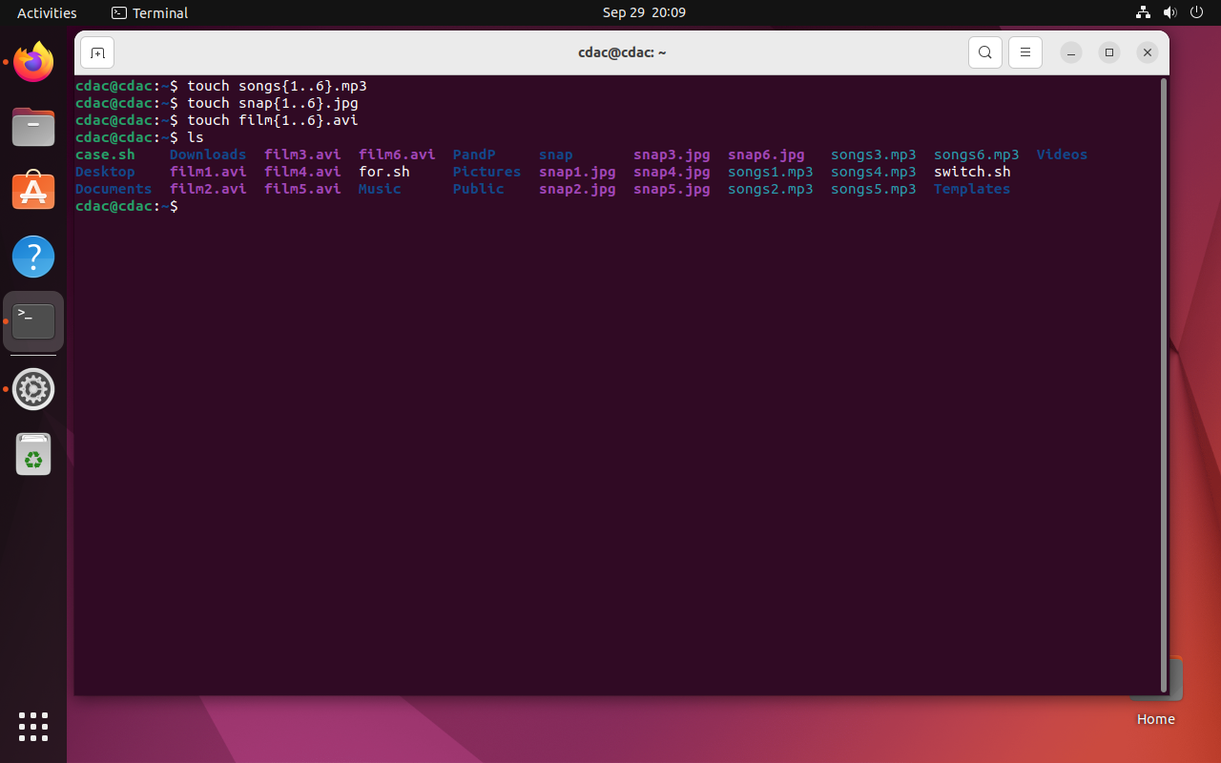

2. From your home directory,

* Move songs file into your Music subdirectory.
* Move snap file into your Pictures subdirectory.
* Move your movie files into Videos subdirectory

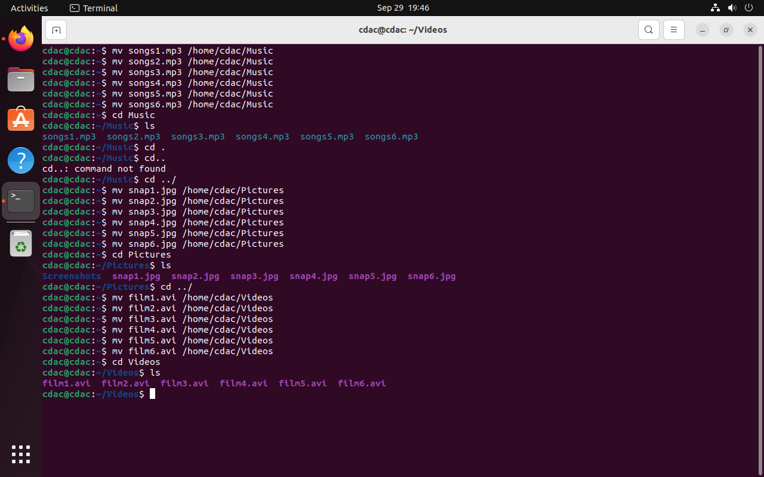

3. Create 3 subdirectories for organizing your files named friends,family,work

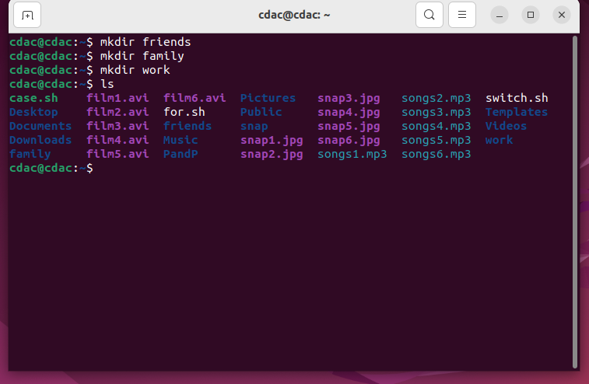

4. Copy files (all types ) containing numbers 1 and 2 to the friends folder.

    Copy files (all types) containing numbers 3 and 4 to the family folder.

    Copy files (all types) containing numbers 5 and 6 to the work folder.

